**Create Bullet Particles**

**Objective**: In this lesson, we're going to do an introduction to particle systems and we're going to use bullets as our example, so that we can create a bullet, laser beam system shooting out of our player ship.

1. First I created a platform under the rocket so I can see the changes easier without it blending into the environment.

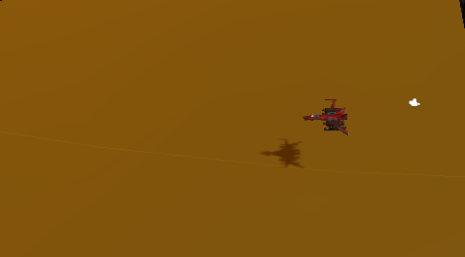

1. I also took a small amount of time to flatten out my map so the rocket continuously travels within the canyon. I also change the Terrains **Base Map Dist** to **2000** and turned **Cast Shadows On.** I've found these two haven't had a huge impact for me. If you want to play around with what has impact for you, that's cool.

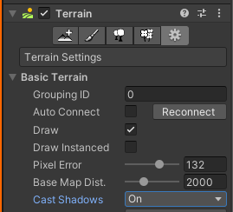

1. What we want to do to start off is to create a particle system that we're going to child underneath the player ship. So if you right-click on the Ship and go to **Effects** and **Particle System**. We get that particle system that's going to shoot out a nice slow kind of boring ray out of the ship which is fine.

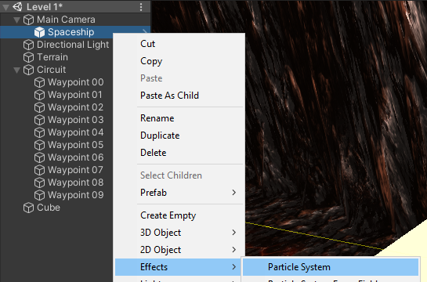

Our goal here by using a particle system is to create projectiles which can be like laser beams or bullets to say, here is the player and down here might be an enemy when a projectile collides with that enemy, then triggers something, for example, trigger an explosion.

1. Rename particle system to **Bullets**.
2. I'm going to start by looking at the texture, or the material that's being applied to each of these particles that's being emitted from this. To do that, we scroll all the way down in the inspector to **Renderer**, click on Renderer to expand that tab, we'll call it. And then at the moment we're seeing **Default Particle**.

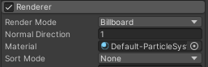

1. Now I'm going to give you guys an asset pack, which will have something called **Particle** **Materials**. Drag it on to the **Assets** folder and import all. You should now have a folder called **Particles.**

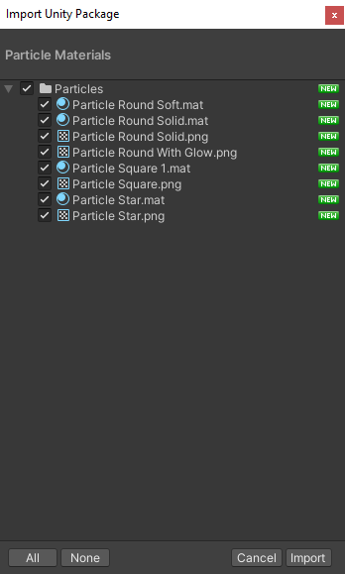

1. Now back in the Renderer tab I’m going to change the **Material** from **Default** to **Particle Square.** That immediately changes all these to square-looking particles.

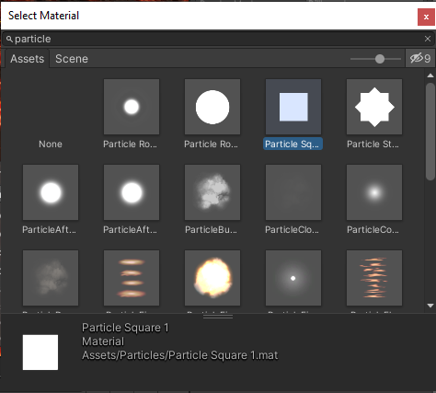

1. Great, this is a starting point, not behaving like bullets just yet. What I am going to do is find the **Shape** tab. This controls how the particles emit from this point. Lets change the Shape to **Sphere** so you can see the effect. We’re going to stick with the **Cone** shape and reduce the **Angle** to **0** lets also reduce the **Radius** to **0.01**. (We could also do this with the box shape.)

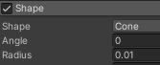

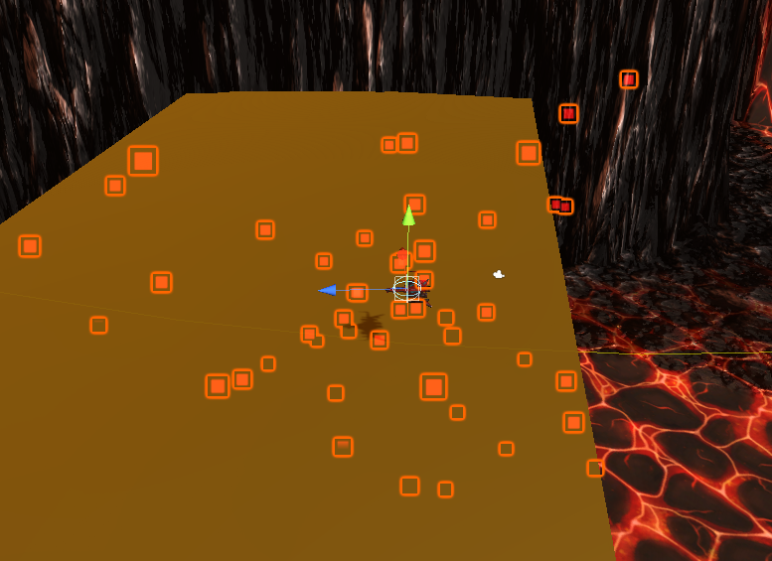

Lets go in game and test it out. One of the immediate problems is we can't reach the **side of our screen here**. 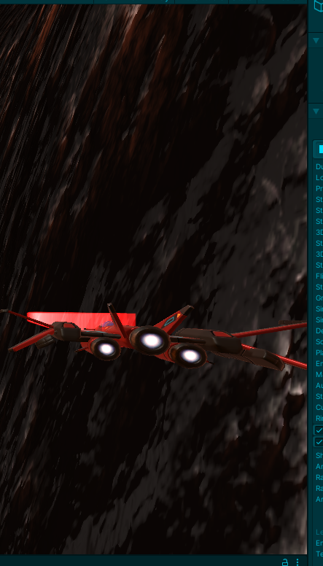

So I'm going have a look on the player **GO INTO PLAY MODE**, see what we can change there. I think if I look at the **Position Yaw Factor** change that to **7**. Now I get a little bit more, like the yaw is looking a little bit healthier and probably allow the plane to go a bit further off the side of the screen so change **X Range to 8.**

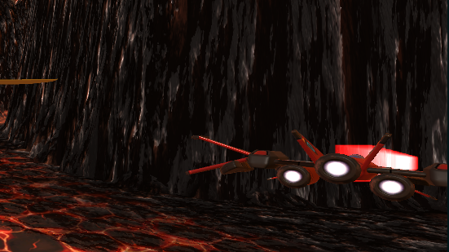

At least this is getting us most of the screen, we can shoot at. And we've got a good visualization of where we can shoot. And I copy the component here, get out of play mode, and then paste that back into component values.

Okay, let's go about making this look a little bit more like a bullet.

Just starting from the top up here, duration if I **turn off Looping** and click the PARTICLE EFFECT **Play button**, you'll see that **Duration** is **5**. That means we will emit particles and then after 5 seconds it stops.

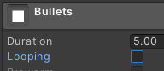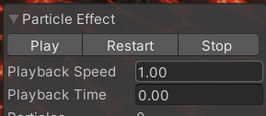

If I was to change the **Duration** to **1 second** and click play, then we can see for one second it emits particles.

How many?

Well, it's emitting 10 particles the right amount of time here per second, duration is 1 second, it's emitting 10. Lets change the **Rate Over Time** to **3**



1. For our bullets, we don't really need to have full 1 second of things being emitted. We want our system to say emit something, stop, emit something, stop, emit something. So I'm going to turn the **Duration** down to **0.2**. Lets go ahead and turn **Looping back on** so we can see the effect of changing things.
2. We can see each individual bullet flying out. And this is not going very far, why is that? Well, first of all, we've got the Start Lifetime of 5 seconds. So each of these is going last five seconds And then it will stop It'll be terminated and no longer be a particle. 

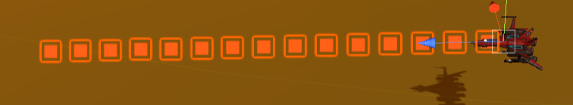

1. If we increase the **Start Speed** to **10**, then you can see they still last for 5 seconds, but then they're going a lot further, because they're going faster.
2. If I was to reduce this **Start Lifetime down to 1**, they're only going last one second and if I increase **Start Speed to 50**, they're going a similar distance the way they were before, but they're going a lot faster to get to that same distance.

So this is how we can play around with how far we want the bullets to go before they disappear and how fast they are. I'm going to turn the **Lifetime** back up to **2 seconds**, they're going to last a little bit into the terrain at the moment, so it's a bit harder to see. And I'm going to increase the **Start Speed to 100**, so they're a bit more like, pew, pew, pew, kind of bullets.

1. The next thing we can look at here is **Start Color**, I'm going to make mine a pretty kind of blue, a brightish blue, if I can find that. Choose whatever you think works.
2. It's important for us to change the **Simulation Space** from **local** to **global**, let me show you what that means. If we fly around at the moment, the particles are being childed to the ship and they're being told to respond in local space. So when the game object here, the main camera Player Ships and Bullets, when that's moving up and down, the entire particle system moves up and down. We changed this to world, then the bullets tend to keep going off where they were shot from. They're looking more like bullets, so it's cool.

**BUG**: At this point I realized my Ship was travelling way faster than my bullets. SO I clicked on the Camera and changed the **Look Ahead For Target Offset** to **0.25.**

1. What I am going to do is add the trail to each of these. Change **the Playback Speed for the Particle Effect to 0.25** and see as a particle comes out, it's moving along certain directory, I'd like to say, let's add a trail to this.
2. So if you scroll down, finds **Trails**, make sure if you're selecting any of these new elements, you click on the **check box** next to it to activate it. We can see that trails being added and we've got the pink material that says, no material is attached.

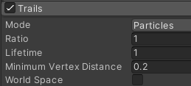

1. And to attach a material you'd think it'd be under trails, but it's actually down here under **Renderer** as well. A new area has appeared, **trail material**.

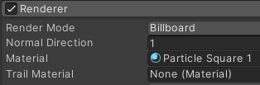

1. Let's click on that, I'm going to choose the same **Particle** **Square material**. At the moment it's all blending together into a big mush. There's too many, the trial is lasting too long. So what I will change here first of all under **Trails** and change the **Lifetime**. I want the trail to last 0.02, may be 0.05.

Now I've got a little bit of a problem, because you can see that the bullet is coming out first and then the trail. Well, it needs to look more like a laser beam that a bullet with a trail behind it.

1. So to do that, first I might need to under **Trails** to **click off** the checkbox of **Size Affects Width**. Scroll back up to our **particle system**, find the size of the **Start Size** of the particle change **to 0.01** which basically makes it invisible.

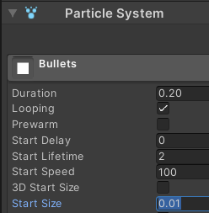

1. There is another tweak to the size of the trail when we are doing the **Width over Trail** in the **Trails** tab I'd like to make this down to **0.3**, so it's more of a narrow kind of bullet.

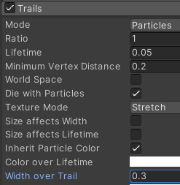

Let's have a look at how that looks when we fly around. Its looks more like a laser beam.

1. At the moment it looks like it's coming out a little bit too sparse, not being emitted enough, so I'm gonna turn my rate over time up to 10 and see what happens.